Mitchell Stevens
Matt Micciolo
Aaron Segal

This design document will cover areas around the set design in the main escape the room, in order to paint a verbal and visual picture of the space. Below will be the areas of focus for this document, in order to use as a guideline for future development of the space.
1. Dimension of the main room and space allocated for certain objects.
2. Lists of props for inside the room
3. Materials needed for the room
4. The procedure of setting up those materials

1.1 Summary
The space being used is the Graduate Lounge located in the sub-basement of Fuller Labs. The space will be divided up into two sections, The Tent, and The Bunker. The Tent will be constructed using several canvas tarps, PVC piping, duct tape, and rope ties. The Bunker will make use of the existing basement walls of the graduate lounge and is separated from the tent with dark canvas, and a sliding wooden door.
Players will enter The Tent through the lounge’s double wide door, which will remain open to the hallway. This entrance will be draped with canvas to create a tent-flap entryway.
The other door in the lounge will be located in The Bunker portion of the set. It will be decorated to transform it from a wooden door into a steel door and will be secured shut using a chain.

As shown below, the tent takes up most of the room being 169.5 inches in length and 225 inches tall. The bunker holds smaller dimensions, with 78 inches in length and 225 inches tall. There are two doors located in the room, one located in the tent in the bottom right hand corner and a door at the top of the bunker. Take notice, there is a small structural support in the bottom right hand corner, taking away from the room.

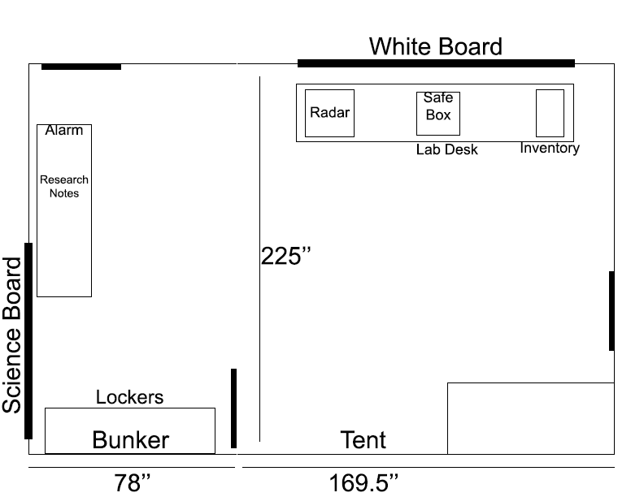

2.1 List of props located in the room

Object's Name | Object’s Description | Owner | Object in possession? Y/N
Sleeping Bag | A blue/grey standard sleeping bag |  | Y
Ski bag | Blue / grey/ and black bag for winter gear | Mitchell | Y
Balaclava | Red, yeti looking balaclava | Mitchell | Y
Ski gloves | Black and thick gloves | Mitchell | Y
Ski bag and skies | Black and white ski bag, red and white skies | Mitchell | Y
Ski jacket | Red white and blue / black color scheme | Mitchell | Y
Winter hat | Green with black/ white tip fur | Mitchell | Y
Outdoor first aid kit | Red case with picture on front | Mitchell | Y
Military bag | Military green, with pouches | Mitchell | Y
Gas mask filter | Silver with words written on side | Mitchell | Y
Gas mask | Black gas mask, with bad tint job | Mitchell | Y
Milk Crate | Black milk crate with handles | Alex | Y

3.1 Materials needed for the room
Below you can find all the materials needed for the construction of each room, in order to fake the appearance of both Tent and Bunker in a lounge.

General:
Duct Tape
Paint (1Gal)
Respiratory masks
Spray paint
Paint Trays
Painter's tape
Speakers
Extension Cables

Tent:
Canvas Tarp (9' x 14')
PVC Lengths (2in X 120in )
PVC T Elbows
PVC Angled, Elbows
Plywood (4 x 8) (2)
Prayer Flags
Radar
Radio
Sleeping Bags
Safe Box
Lanterns
Cans of food
Tables

Bunker:
Plywood (4 x 8) (2)
Preserved “yeti” parts
Yeti Fur
Alarm Lights
Science Supplies
Locker
Crates
Sleeping Bags
Cans of food

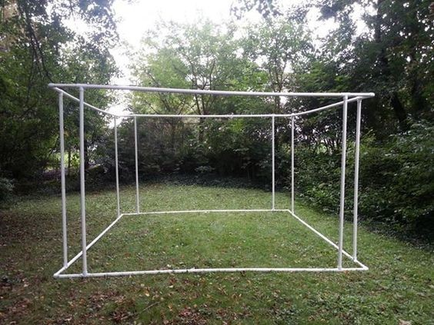
4.1 The procedure of setting up those materials
With the above materials, we will be creating an area for a tent and an area for a bunker. For The Tent, we will be using a framework of PVC pipes to create the general framework for The Tent, shown to the right.
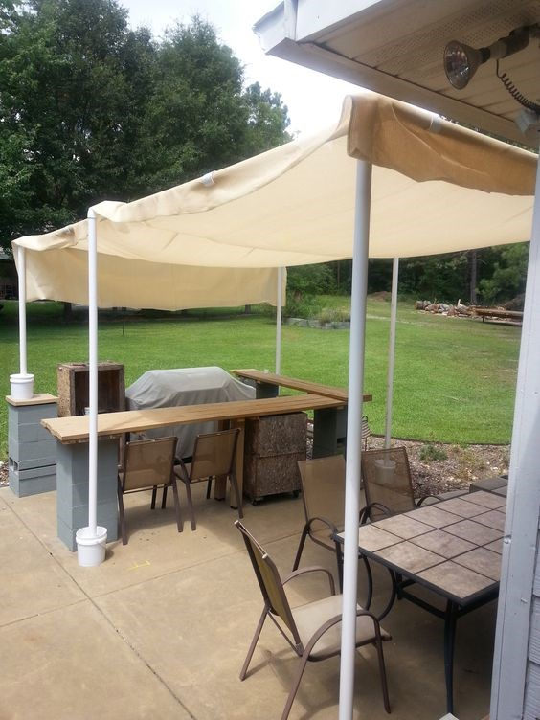
Once this framework is set up, we will be adding canvas tarp in order to create the flaps for The Tent. Once painted, the results will look like something in the picture to the left.

