Worcester Polytechnic Institute

Small Project for Haptic or Input Experiment

Bolin Zhu
Mitchell Stevens
Jing Xiong
IMGD 5100 Immersive Human-Computer Interaction
Prof. Jeffrey Kesselman

Introduction

Brief Introduction
This paper presents an experiment testing the key elements in a horror game, most warrant further investigation as a means to control the level of fear in such games. The experiment is part of a human computer interaction course project ultimately designed to support the game level design for VR horror game. By this means, it is hoped to provide an enhanced gaming experience whereby periphery and third party wearable device is conducted in real-time according to the player’s affect response and emotional state. Results indicate that periphery has the potential to influence the intensity of the player’s fear response while playing a horror game. Evidence is also presented that supports the integration of event triggers and real-time participant heartbeat rates into an experimental design to gather unbiased, quantitative data that can be associated with qualitative emotional response.

Goal Initialization

Enhance the gameplay and display of a horror game
The purpose of our project is to combine the experience of virtual reality and real world. We aim to use technological device to transform the virtual world into a 3D dimensional space, and to create a physical experience for the player. More specifically, the project is to evaluate how techniques we use work together to generate an immersion for players. To conduct the experiment, we will use HTC VIVE and TN Games 3RD Space Vest as wearable devices. Players will play in the virtual space we designed. We will test several movement options for our project: teleport, point and click to move with reticle, and no movement. And an oximeter will measure the heartbeats during the play process. Data will be collected and compared to analysis how well the game and the devices together deliver the immersive experience.

Background

Horror Game History
The concept of fear in fictional media such as computer games, may be broken down into the concepts of horror and terror which Varma[11] describes respectively as the sickening realisation and the awful apprehension. Horror game is a subgenre of video games inspired by horror fiction that focuses on survival of the character as the game tries to frighten players with either horror graphics or scary ambience. Although combat can be part of the gameplay, the player is made to feel less in control than in typical action games through limited ammunition, health, speed and vision, or through various obstructions of the player’s interaction with the game mechanics. The player is also challenged to find items that unlock the path to new areas and solve puzzles to proceed in the game.
In horror games, they commonly challenge the player to manage their inventory and ration scarce resources such as ammunition. Another major theme throughout the genre is that of isolation. Typically, these games contain relatively few non-player characters and, as a result, frequently tell much of their story second-hand through the usage of journals, texts, or audio logs. While many action games feature lone protagonists versus swarms of enemies in a suspenseful environment, survival horror games are distinct from otherwise horror-themed action games. They tend to de-emphasize combat in favor of challenges such as hiding or running from enemies and solving puzzles. Still, it is not unusual for horror games to draw upon elements from first-person shooters, action-adventure games, or even role-playing games. Horror game is different from typical game genres in that it is not defined strictly by specific mechanics, but subject matter, tone, pacing, and design philosophy.

Elements in Horror Game

Disempowerment in horror game

Isolation in horror game
When we live in life, we seek community, guidance, and help from others. We come into this world connected to other people, and grow up depending on them. It takes years for us to truly function without another individual, but we still need people and find comfort in the presence of others. When we are isolated, it is natural to feel scared. Horror games capitalize on this by putting players in situations where they are alone. Having to explore a quiet town or a mental hospital by yourself is a typical horror scenario. Just being alone in an environment, hearing only the wind or the rustling of leaves or other more ominous sounds is creepy. Games use this tactic even better when they show you that it is possible for you to be with others, but a certain situation prevents this. “Dead Space” is a game of isolation that sometimes shows other characters trying to interact with you from far away or behind thick glass. You are still alone, and it is painful and frustrating to see the potential of safety with others.

Tension in horror game
Tension in video games is derived from mental or emotional strain. Horror games must have tension to be successful; you cannot have your player comfortable or confident as he or she plays through the game. Tension is achieved in a variety of ways. The first comes from the disempowerment aspect: resource management. Nothing is more stressful than having no weapon and untold numbers of threat in a horror building. Having to scour an area for items that can defend yourself adds to the tension of a game. It also puts players in a positions of agency whether he or she should explore the room.

Uncertainty in horror game
If knowledge is power, then a lack of knowledge is weakness. This why we are afraid of the dark. It is not darkness itself that we are afraid of, but fear of what could be in the dark. In essence, your mind becomes your greatest enemy. A common theme in successful horror games is just that: keeping players in the dark by forcing them to imagine what the horror is. No matter how scary a monster is, your mind can make it scarier; that is why good horror games do not immediately throw the enemy right at you or explain to you what it is. Uncertainty plagues your mind with fear-seeing a quick passing image in your periphery, a tentacle pulling back into water, a snarl in the distance. These fleeting images build up a horror game, adding to uncertainty. Showing the monster, then explaining it with loaded exposition, is a huge shortcoming because it empowers you with knowledge. Not knowing heightens your sense of vulnerability and adds to fear.

Lingering fear in horror games
The best horror fiction puts something into the mind of the one experiencing it, something that stays with you after you’ve put down the controller or closed the book. Most people who saw the movie “Jaws” for the first time experienced a lingering fear of sharks, their mind straying to bloody attacks as they tried to enjoy the tranquility of the oxea. It is a fear that remains with you long after you have watched the movie. Great horror games do not stop scaring you after you are done playing; the fear lingers until you can finally purge it.

Similar genre games
A great horror game is about psychology, exploring what it means to be human and the hard truths about mankind’s flaws. Psychological horror is central to these games when done well. In many cases, the game explores how humanity is the monster, causing you to reflect on yourself and others after you’ve turned off the console. Games like “Resident Evil” show that, despite all the horrific creatures spawned out of Umbrella Corp, the people making these things are just as, if not crueler, than the monsters.
A common horror trope is to have survivors of an apocalypse turn out to be the real monsters. Games like “The Last of Us” pit players against transformed fungal mutants, who attack on instinct, and the surviving humans, who actively and willfully pillage, rape, and kill. This leads us to the question: Who are the real monsters? What is real evil—those who act on instinct or by choice?
In “The Last of Us,” the mutants, while seemingly mindless, were once humans whose brains were shut down by a fungal infection. While sneaking through the game, you see some of them standing still, weeping and moaning. Are these people trapped in their own minds and, every once in a while, their memories surface and they’re overwhelmed by the grotesque reality of what they’ve become? They aren’t technically zombies; they’re still alive—and maybe still human. This causes anxiety in players as they reflect on the possibility that they are killing people who might be silently screaming in their minds for help, horrified by their inability to stop their own attacks.

Prior Research

Description
We have already conceptually proved and demonstrated our theory of generating and delivering a horror experience to players by integrating TN Games 3rd Space Vest, implementing variety of haptics and inputs into Vive, and using oximeter to objectively measure the result. Nonetheless, it is still slightly early to evaluate the integration and implementation of our technologies and techniques at this phase. As for prolongation, some extension of additional devices could significantly benefit our project such as a suit with controllable haptics and integratable oximeter.

Steps to conduct experiment
Step 1 (Subjective): Test different types of movement ( Teleporting, point and click to walk and only player based movement in a small room)
Step 2 (Subjective): Test the vest for haptic feedback, to determine if it improves immersion or decreases immersion due to air compressor.
Step 3 (Objective): Set up the oximeter on the player's arm, which will send data to the main computer.
Step 4 (Objective): Outfit the player with the HTC Vive headset and two controllers, with addition of the haptic feedback vest
Step 5: (Subjective): With group tests, determine if the art style and sound provided will add to the immersion.
Step 6: (Subjective): Monitor players heartbeat through the oximeter, to see if any visible changes occur during gameplay.

Result
 | Teleport | Point & Move with reticle | No Movement
Subjective | Teleporting will break immersion, due to it being unrealistic in nature | This will cause the player to be somewhat motion sick due to them not moving in real life | Free form movement controlled by the player will allow the player to be immersed, with their movements acting out 1 to 1 in the game
Objective | Lacking the oximeter, we cannot yet determine break in immersion | Lacking the oximeter, we cannot yet determine break in immersion | Lacking the oximeter, we cannot yet determine break in immersion
Table 1.1: Subjective and Objective views of movement in the virtual space.
Since we do not have an active oximeter ready for use, we will not be able to gauge our experiment with objective views. So far, subjectivity among internal group would be the major evaluation for our project.
According to Table 1.1, we decided not to implement any movement into the game before we are able to find out any better options for our final project. Instead, the game space will be limited to the given area that Vive provides. Although the limitation of game space is cruel, it limits down the need of visual assets. Even better, it also benefits us on increasing the feeling of claustrophobia.
 | With Vest | Without Vest
Subjective | Using the haptic feedback on the vest, the player will feel more immersed due to getting touched by the ghosts in the game | The player will have the immersion broken due to seeing the ghost touch you but with no feeling of the touch
Objective | Lacking the oximeter, we cannot yet determine break in immersion | Lacking the oximeter, we cannot yet determine break in immersion
Table 1.2: Subjective and Objective views of using a haptic feedback vest when being touched in game.
Based on Table 1.2, implementation of TN Games 3rd Space vest is certainly the selling point of our project which provides better feeling of haptics on upper body. Indubitably, it is surely a plus and worth having the vest integrated with our game. Yet, as being said that a coin has two sides, the vest has its own restriction of fulfilling our needs on full body feedback. In a horrifying scenario, lack of interaction with lower body would be crucial for the fact that human feet seem ignorable to players but sensitive enough to provide a terrifying shock. Not only that, the device itself has a air convertor that makes an extent of noise which might limit us on choice of background music and sound effects.
Having an oximeter to measure how well the game delivers the horror experience, we currently have limited options to do with the device. Though the oximeter might transmits data we need, it is not able to provide data that is in real time and digitally transmittable for us to analyze the outcome correlated with the game progress.

Project Scope

The Game Environment Chosen
Single player was chosen for the prototype over multiplayer because of this, and as it creates less variability and potential issues in evaluating user experience. Multiplayer or collaborative games may influence player reaction through other users in the world, and such is difficult to gauge whether the change in reaction is based on the enhancement of the game.
We decided that the horror and puzzle style of gameplay provided the most gameplay to the elements that could be enhanced. It was anticipated that this style would also cause the most variation in the information that was collected.

The Engine Chosen
For this game, we want to test the horror scene, combined with animation and sound. After compared with different game development engines, we decided to use Unity. Unity is generally seen as the more intuitive and easier to grasp game engine. It has excellent balance of ease of use and power. Built in physical based rendering and extendable rendering pipeline all very high end graphics performance. In addition, c# is an expressive and powerful programming language that is relatively easy to learn. Solid content pipeline makes it near effortless to bring in content from a huge variety of tools. What is more, extremely robust asset store has many useful add ons and content and also is a potential revenue stream for our developers.

Date Collect Device
To collect the real time heart-beat rate of the players, we searched for several oxmiters, and found out both the Fitbit and the Apple Watch work. To compensate for possible problems associated with this method of analysis, data were averaged at two- second intervals. This reduced the deleterious effects of any possibly incorrect data, and provided an accurate representation of the participant at the particular time. The current average of the participant’s heartbeats were used to dynamically change the game environment.
One of the greatest features in terms of health and fitness, introduced by the Apple Watch, is its ability to efficiently measure your heart rate, at any given moment in time. Data is recorded and synced with the Health App, available on the paired iPhone. This allows you to track your heart’s performance throughout the day. The photoplethysmography heart rate sensor, available on the Watch, uses light to detect testers’ heart beats. Although the name is complicated, the technology is very simple. The human blood has a red color because it reflects red light, while absorbing the green luminescence. Thus Apple’s engineers have equipped the back of the Watch with two LED lights, that pulsate green light hundreds of times per seconds, towards our wrist. Available are also two illumination sensitive photodiodes. Their job is to detect the reflected light from testers’ arms’ blood vessels. When a heart beat is occurring blood is pushed through the vessels and green light absorption is enhanced. Between beats, the reflection differs thus allowing the smartwatch to distinguish beats. Next, the wrist gadget applies a simple mathematic formula that allows it to come up with an accurate heart beats per minute (bpm) figure. Whenever we inquire for the heart rate, the Watch scan pulse for 6 seconds and multiples the outcome by ten, to come up with the bpm rate. For example, if it measures 7 beats within 6 seconds, the displayed heart rate will be 70 bpm. The longer we let our Watch OS gadget measure the heart beats, the more the readings will adjust and the results will get even more accurate. Whenever we wish to find out testers’ heart pulse, simply flick the wrist and press the Digital Crown, until we reach Watch Face. Swipe up, to open glances and browse to the Heartbeat summary. On this view, we are prompted with the value of the last reading and the time when it was recorded. If we remain on this glance’s view, or tap the red heart, a live measurement starts. The first heart rate results are displayed within 6 seconds and further adjusted, the longer we allow our gadget to scan our blood flow. Contrary to other glances, tapping the screen won’t open the full Heartbeat app, simply because there is not any. All data is saved and downloaded to the paired iPhone.

3rd Space Gaming Vest
Throughout the experience of working with technologies we have never played around with before, the gaming vest was one of interest. From initial tests, to the ultimate decision to remove it from the final project and tests, the gaming vest was a robust piece of equipment but in the end, did not suit our needs.
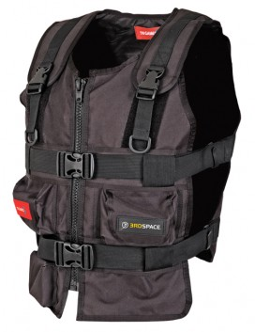
The 3rd Space Gaming Vest was created by Tngames, mostly for first person shooter applications. Suited with eight active zones, four in front and four in back, it allowed the player to be immersed in the game using a high powered air compressor. When triggered, the vest would expand one of the eight active zones, giving haptic feedback to the player, through the burst of air in the chest or back.
The full description on the Tngames website states “Turn on your sense of touch and circumvent in-game danger by tapping into your body's capacity for instant reflexive action. 3rdSpace's unique sensory realism gives you a fully intuitive sense of orientation and action within the virtual environment. Our VR interface heightens your state of awareness and accelerates decision-making to give you the overall competitive advantage. Experiencing the game as a real, physical, 3-dimensional place means you are undeniably part the action. It's much more fun and intense having a presence rather than being a bystander. Go beyond rumble and feel what you’ve been missing!”
Figure 1. 3rd Space Gaming Vest

Prior research
When researching about gaming vests being used in video games or interactive media, there were only a handful of research articles about the topic. Our initial response to this was the effects on immersion with gaming vests have not been tested, making us one of the few diving into this subject.
An article called “Feel Effects: Enriching Storytelling with Haptic Feedback.” did not go into gaming vests but with generalized haptic feedback for the user. Examples of some of the feedback tested were rain, cat purring and finger tapping, administered by a pad, which is shown below. 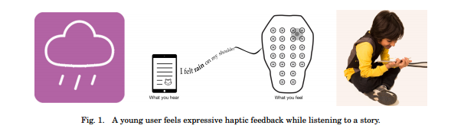
The results of this study, showed “Our initial experiment demonstrates that users who have only their intrinsic language capacities, and no haptic expertise, can generate a core set of feel effects that lend themselves via semantic inference to the design of additional effects. The resulting collection of more than forty effects covers a wide range of situations (including precipitation, animal locomotion, striking and pulsating events) and is empirically shown to produce the named sensation for the majority of our test users in a second experiment. Our experiments demonstrate a unique and systematic approach to designing a vocabulary of haptic sensations that are related in both the semantic and parametric spaces.”
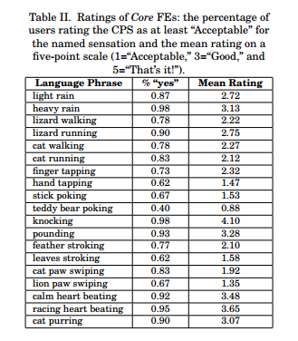
What this research showed, was haptic feedback can possibly have a positive effect on the user, if these were used in a gaming application. Since our VR horror game is attempting to bring as much real life haptic feedback into the game, this information helps support the aspect of that feedback. The next research article discusses immersive gaming technologies in regards to game transfer phenomena.
In the article “What can Game Transfer Phenomena tell us about the impact of highly immersive gaming technologies?” it talks about effects on the players, being negative or positive. The aim of the paper is listed “to discuss the challenges highly immersive technologies posit to the malleable human mind, taking into account not only the side-effects of the virtual immersion manifesting as physical symptoms, but also the psychosocial implications.” Those effects discussed in the study are listed below.
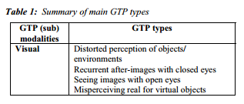
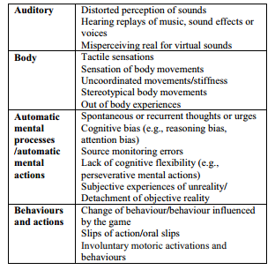
The conclusion of this article showed, “Game Transfer Phenomena (GTP), a research approach focusing on understanding the psychosocial effects of video game playing by examining non-volitional phenomena (e.g., altered sensorial perceptions, automatic mental processes, involuntary motoric activations and behaviors related to playing video games), suggests similarities between gamers’ experiences reported after playing on conventional devices and side effects of highly immersive technologies (e.g., head-up displays, highly realistic virtual environments)”
What this article surfaces, is the need to look into the effects of immersive type of technologies, like a gaming vest for example. Since we are diving into the effects of the players inside the game, this type of research helps us understand that this is a current concern in the industry.
Besides the above two articles, not much else was found on gaming vests and immersion. This leads us to believe not much research has been conducted and our findings could be highly impactful. In the next section, we are going to be applying the vests with game tests, while recording heartbeats, to determine if this gaming vest is a viable piece of technology to use for these types of games. With comparing tests with players with and without the vest during gameplay, we can formulate the immersion of the players.

Gaming Vest’s role in Research
To determine if the vest was a plausible addition to VR, two sets of data were needed. With the number of testers we had, we split them into groups, one with them wearing the vest while the other did not wear the vest. To determine its effectiveness, heartrates would be recorded, and compared. This comparison would determine if the Gaming Vest increased or decreased the overall immersion of the experience.
Walking into the experiments, our team hypothesized the vest was going to decrease immersion, due to its limitations. With the very noisy compressor, and short wires, we believed to see decreased heartrate as a result of this broken immersion. If found to be not immersive, the vest would still be a viable piece of equipment for other genres in VR but for physiological horror games; it would be obsolete. However, if found to add to immersion and increase heartrate of the tester, then it could be an additional tool for developers to create a realistic VR application.

The Study
The study consisted of two main groups, one with the vest and one without. The ones with the vest, had their base heartrate recorded before putting the vest on. Once the vest, VR headset and controller were fitted, the game was then played. The experiment stopped for only three conditions: If the player decided to quit the game before completion, if the player completed their main objective and if the player got lost in the environment, then the developers pulled them out. During this experiment, one of the researchers were monitoring the heartrate, while another researcher prompted when a trigger occurred. Once the test was complete, the tester was thanked and all heartrate data was collected and stored.

Methodology
The methodology of this project revolves around the complete immersion of the player in the virtual space. Using the HTC Vive virtual reality headset, TN Games: 3rd space haptic feedback vest and an oximeter, we intend the player to be as immersed in the virtual reality as in real life. This immersion, to simulate real life encounters, will measure the player's heart rate when playing this horror based game. As noted down below, the end result is to record the player's heartbeat to notice significant changes and to determine the highest heartbeat recorded.

Graphics and Sound
To achieve enough immersion, the technology being used and the visuals will need to work hand in hand. Regarding the visuals, no matter the scene provided, will be high quality models that mimic their real life partners. When a player is brought to this virtual space, the realism presented will trick the brain into believing they are still focusing on real life, not a bunch of pixels on a device. Another important part is the sound design and the sounds being heard by the player. 3D sound will be presented to the player in order for them to feel more immersed inside this environment. The sounds will also mimic the objects real life sounds, like a grandfather clock to footsteps on a wooden floor.

Controls and Inputs
The technical part of the project is where added immersion will be added, starting with the virtual reality headset, the HTC Vive. This will give the player 120 degrees of vision, simulating real life vision, giving the player a personal first person perspective in the virtual world. Along with the headset, there are two Vive controllers the player will have when in this space. One will be controlling a flashlight, and where the controller is pointed, will also move the flashlight. The other controller is undetermined at this point of time, either it be a free hand for interaction of objects or holding a device of some sort.
The experiment is to gauge how technologies and techniques we’ve been using generate the horror, immersion for the player in a sense, delivering the feeling of spectrophobia and claustrophobia. To fulfill the requirements of immersing the player while playing the game, we need to control inputs.
One of the ways to reduce the possibility of breaking immersion is to limit inputs from the controllers by only allowing the player to press buttons that make sense in the game world. For instance, in one hand the player should hold a button or press a button to keep on or turn on a flashlight for the purpose of light source; The gesture and feeling of holding a flashlight are almost the same in both reality and virtual reality using Vive controller.

Movement
As stated based on most virtual reality experiences, the movement is always the major issue that breaks immersion at some extent. We decided to try out several movement options for our project: teleport, point and click to move with reticle, and no movement. Based on research result that a reticle would help players maintain balance and reduce motion sickness in games [3], we decide to add a reticle into our game to balance out the motion sickness. Though it might break immersion a little bit, we think it is worth trying and a good trade-off to keep players in a good state of entertaining. In addition for final project, the reticle could be textured to make sense to players that may reduce inattention from the game.

Movement in VR
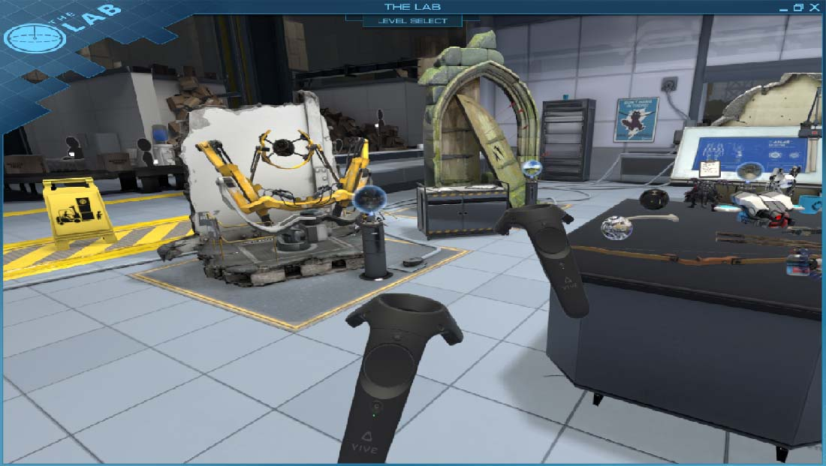
Figure 5. The Lab in Virtual Reality
The traditional way of moving in virtual reality consists of teleporting to a certain area. The reason for this is due to the high risk of motion sickness inside virtual reality. With this teleporting feature, it moves the player without actually moving, making the inner ear content. Games like The Lab and Rec Room use this teleporting as its main movement, to reduce this motion sickness.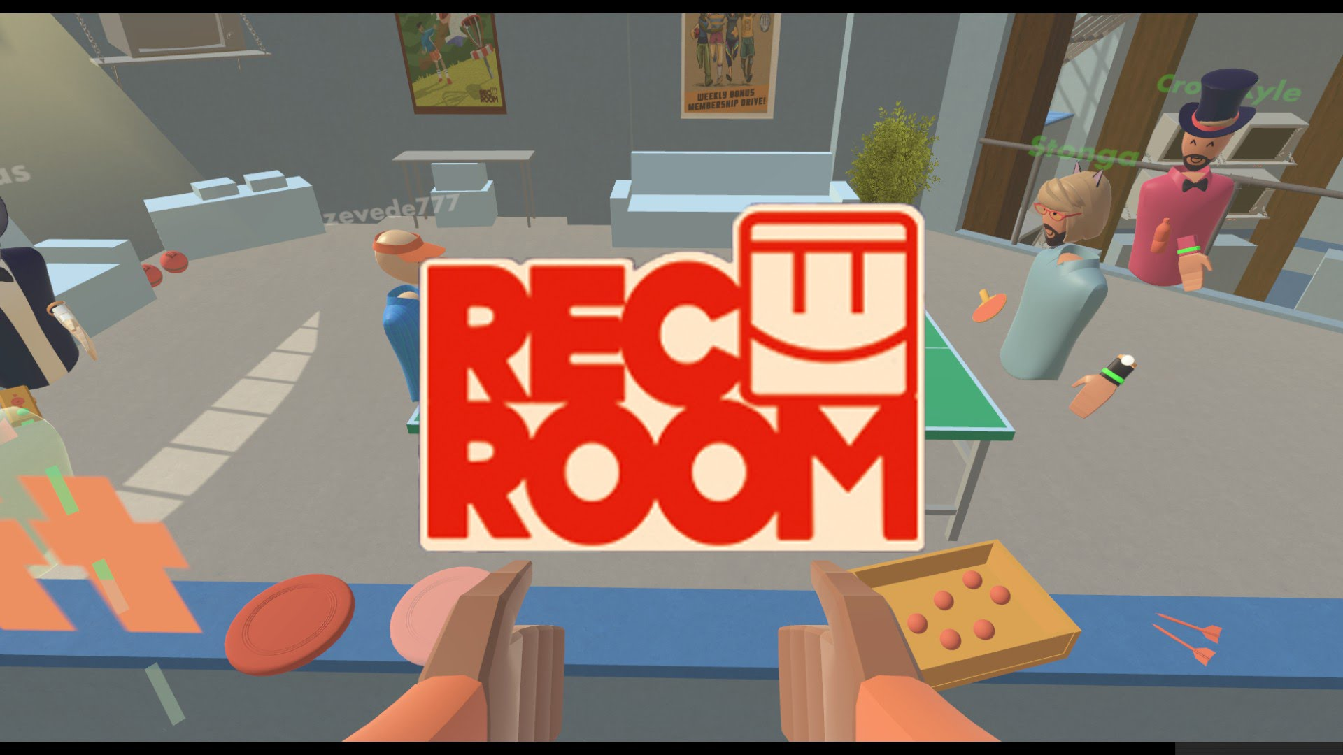
Figure 6. Rec Room

When designing our game for VR, we had to look toward ways of moving inside the environment without getting the player heavy amount of motion sickness. Different types of movement were looked, for example, teleporting, point and walk, no movement at all and Xbox controlled movement. In the sections below, we will discuss each test used and why we picked the method of walking we picked.

Teleporting
Being one of the most popular choices for movement in a virtual reality game, we started here. However, it quickly became apparent that this type of movement would not work for this type of game. For our game, we are trying to fully immerse the player with graphics, audio, and movement. With teleporting, it’s impossible for a real human to teleport at will, therefore reminding the player they are only playing a game. Another reason for not including this method of movement was due to the possibility of teleporting over a trigger, and having missing data.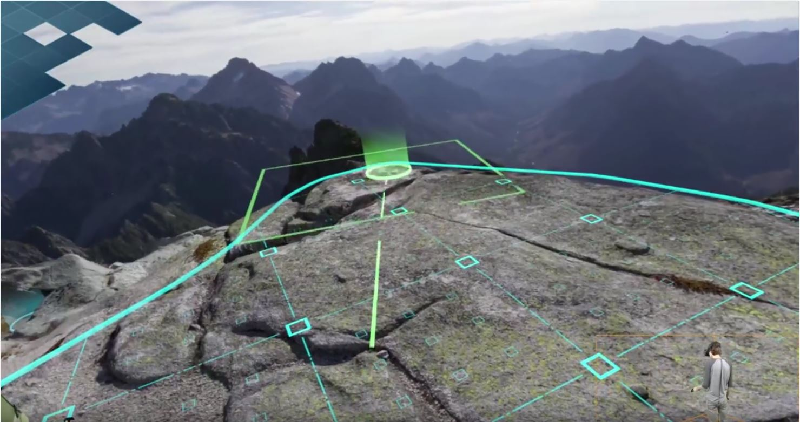
Figure 7. The Lab way of movement

Point and Walk
With the point and walk type of movement, it would add that realism of walking, but would increase motion sickness with the user. For our small project, we tested the method of point and walk, in a small hallway with a few obstacles. After testing, we found this method to be motion sickness including, due to you moving in the game and not in real life. We adjusted speed of the walking and also added a reticle, which will be discussed later in the paper, but it felt disconnected from the player. With point and walk, you had this giant arc of the path you are going to take, taking up some of your screen. Regarding immersion, we felt this type of UI would destroy some of the immersion in the scene.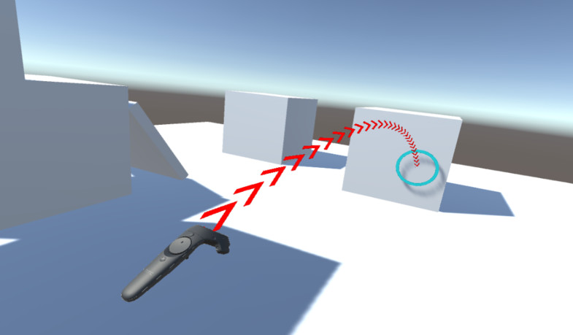
Figure 8. Point and Walk example

No Movement
With no movement, the player is still allowed to move around in the borders defined by the lighthouses but that is it. Games with this type of movement have only one room and the main story plots occur in said room. Games like Job Simulator take advantage of this, as the player role plays a person at a desk job. Early in our design, we were trying to eliminate all motion sickness and no movement came up. The game would only take place in one room, and the triggers would be there as well. However, after some thought, it was decided to be very limiting in nature. To have multiple triggers and a diverse environment, was one of the main goals of this project and only having one room destroyed that.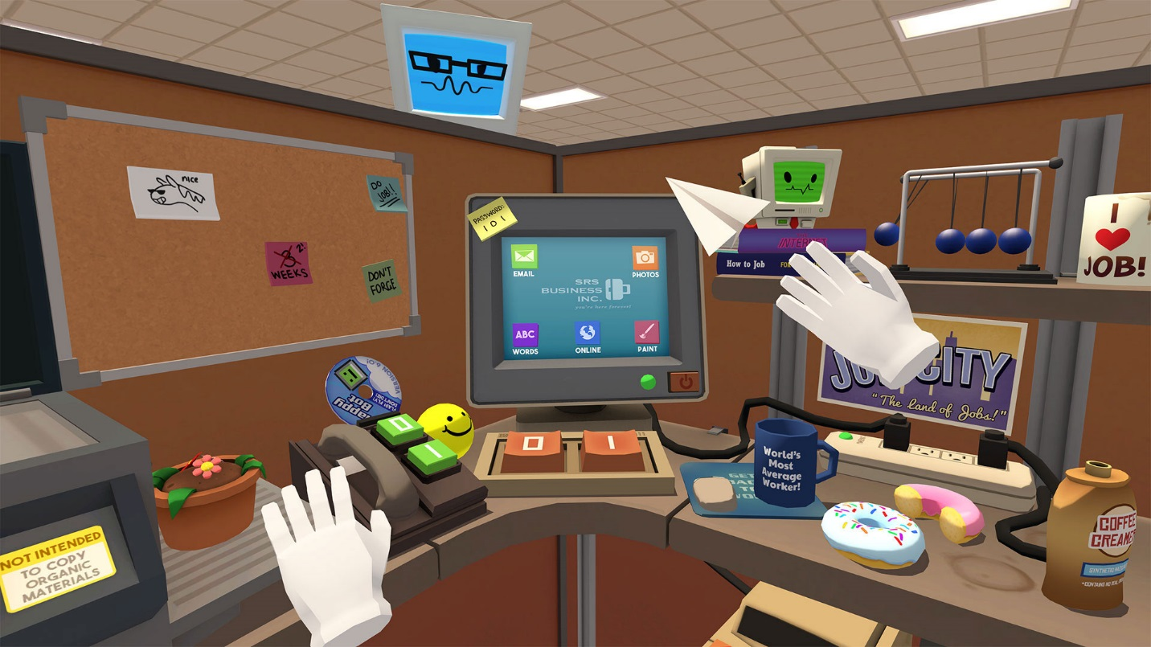
Figure 9. Job Simulator

Xbox Controlled Movement
In our final game, we decided this type of movement was great for our game. With the player controlling their movement by the analog stick, and their head being used to point in which direction, it created this unique mashup that worked. Some users did report minor motion sickness but a reticle was added to dim these effects. The movement seemed controlled without actually moving. We did notice, however, that there will always be disconnected with the player and movement, and only new technologies can attempt to tackle this issue.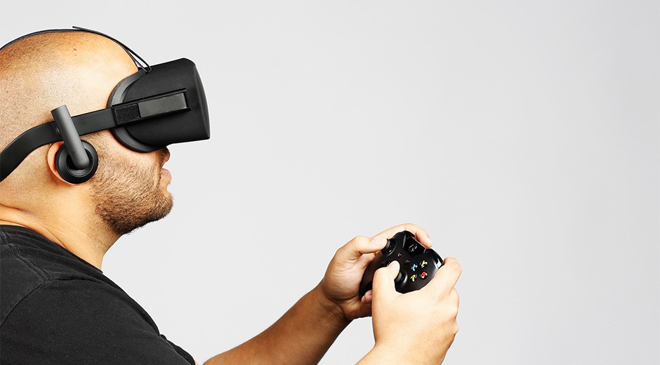
Figure 10. Xbox control with VR

Reticle Use in Virtual Reality
Reticles are present in most games, be it first person shooters or even MMO’s. An article from Polygon discussed motion sickness in video games and whys to combat it. When discussing about reticles, it was said “ICE placed a tiny dot in the center of the screen for its game, giving players one point to focus on while moving protagonist Faith through each parkour obstacle course. Techland has done the same for Dying Light, Binkowski said, and added a small dot to the center of the screen to help players maintain balance.” 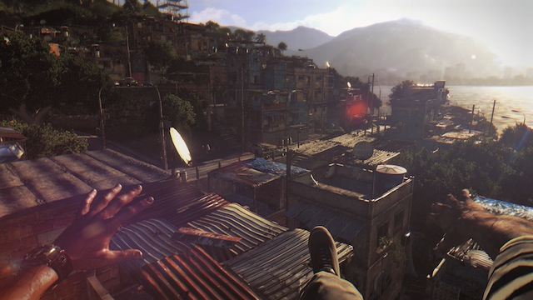
Figure 11. Dying Light

Having seen this article and dealing with motion sickness problems ourselves, we decided to add a reticle to give the player something to focus on. During testing, we determined it reduced motion sickness in players even to the point not many complained about the sickness. In conclusion, thanks to the polygon article above, we learned that reticles have a huge power in reducing motion sickness.

Integration of TN Games 3rd Space Vest
The innovation in our methodology is the TN Games: 3rd space haptic feedback vest, which will provide more feedback for the player. This feedback vest has three air pockets on the front and four on the back. When triggered, will simulate either being touched, punched or even shot. The player will experiences this force when an object in the game presses on their chest or their back, setting off the air pockets.

Involvement of Oximeter
Due to all of this immersive technology, we will have the oximeter to measure the heart rate of the player during the experience. From the one minute “Peaceful” scene to the panic inducing version of the scene, we are looking at the differences in the heart rates. Through the graphics, sound, virtual reality headset, and feedback vest, we hope to provide a close to real life experience inside this virtual reality, with the oximeter to measure this.

Challenge

Performance

Problem Description
When we worked towards to the test phase with some final touches of the game/project, we were facing a problem that most games will need to deal with: performance. At first a couple of internal experiments on integrity and completeness of the game, we realized that we could actually see and feel the images shaking while turning our head around during play in Vive headset. It was really causing nausea and breaking immersion badly.

Problem Analysis
It was quite obviously a rendering problem, but we did not know what the cause of such a rendering issue was. Through observation, we found out that it happened when frame rate dropped to 5 – 10 Hz. Thus, we did a small experiment to locate the cause of the issue by turning on/off the possible factors one by one.

Possible Factors
- Script
Some scripts could possibly cause performance issues like time complexity greater than or equal to O (n^2) for fairly large dataset. In the Unity engine, Update method is being called each frame; it might result in some trouble if some function is too massive and expensive.
- Lighting
Lighting in Unity3d Engine is pretty expensive. To fulfill the need of horror theme, besides images, lighting is pretty much the most essential element visually.
- Rendering
As mentioned, image is the most essential element in a VR game. Models being realistic are quite important. The trade-off for models being close to reality is that the performance will drop drastically, because it is very expensive to render models that are very detailed.

Experiment of Locating Problem
The experiment will disable the factors one by one to inspect the change of frame rate for evaluation of the extent of each factor. The frame rate with everything on is around 10 - 15 frames per second.
- Disable Scripts
We disabled most scripts except movement script which was proved working effectively in every game. And we gauge the performance based on the frame rate change. Then, we tested the game by walking around the level to record the frame rate which is quite steady at around 10 – 15 fps like it was before experiment.
- Disable Lighting
In this one, we found that the frame rate is back up a great amount to around 35 fps. It was proved that the lighting is somewhat a reason of causing the performance issue. However, due to the approach of our horror experiment, there is not much of adjustment to lighting that could be done to improve performance. This will be discussed in later section.
- Procedurally Disable Models
In this part, instead of disabling all models, we decided to test the influence on performance by models, because there is no scientific value for not rendering models in a game to prove that the models effectively affect performance. Thus, we decided to disable models procedurally—we partitioned our level into sections and disabled them one by one to see how much would keep performance, we gauge with frame rate here, above 60 fps which is proved to the best frame rate for normal human eyes [1].

We partitioned our level into eight nearly-equal-size sections based on the layout of the level which appears to be somewhat eight sections. Then, we did our little experiment on the evaluation of performance by disabling one section at a time in order. Then, we found out that the frame rate could be constant above 60 fps to display four sections at run time and more than 120 fps to display only one section.

Address Problem & Solutions
According to the small experiment described in section 1.2, we found the major cause of the performance issue: lighting and model rendering. There are several possible solutions listed below:

Adjust Lighting
As we mentioned, lighting is fairly important in a horror game/media setting up the mood and delivering terrifying moments. Adjustment to lighting for better performance means that we need to reduce quality of lighting on objects by lowering reflection, ambience, emission, etc. However, lighting is too important to be neglected for better performance. After having done some possible adjustment to lighting, we, therefore, decided not to touch lighting to improve performance.

Reduce Asset Quality
There are several ways to get lower quality assets for the purpose of better performance: mainly texture and model polys.
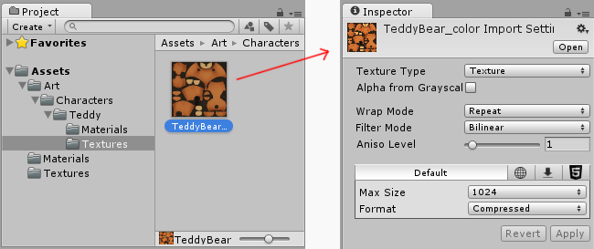
- Reduce Texture Quality/Size
In the Figure #, we can see that Unity import setting for texture has Max Size and Format for adjustment of importing textures. Easily, it can be done by just change Format to “Compressed” and adjust Max Size to whatever is needed. After some trials of this method, we found that adjustment on texture quality along with change material quality for models actually killed the mood and realism of the appearance of the game/project. Thus, this method would not help that much for our game due to our approach of measuring players’ fear.
- Reduce Model Poly

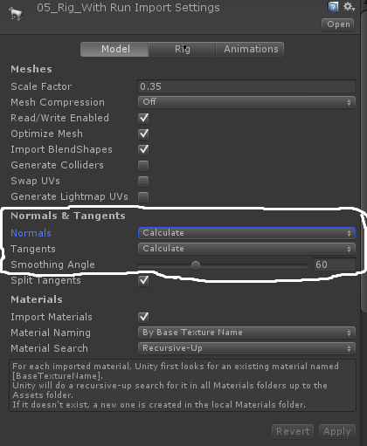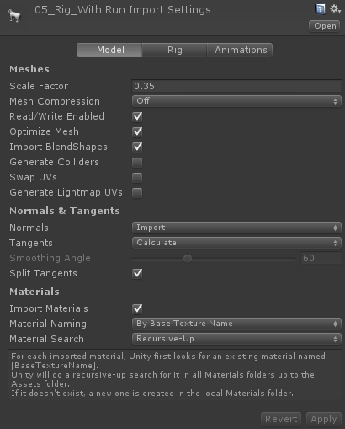

Similar to last method mentioned above by reducing texture quality, this method of reducing model poly faces the same downside in a sense of that texture and model both drastically affect the appearance of the game/project. As you may see in Figure #, the model will be imported as a lower poly model if we select “Calculate” in Normals. The result was, as expected, the same as the result of reducing texture quality—it will make the game less immersion due to its low visual quality.
- Change Rendering Method
The rendering method was simple before the performance experiment: render everything upon launching the game. It works perfectly for small-scale games which do not have many models to render. However, it is terrible for large-scale or highly graphical games like our project. There are several approaches to address the problem [2]:
- Render Visible Objects
- Render Objects In Range
- Render Objects By Sections
The core principle here is to render what is and is about to be seen, and to free up rendering process by ignoring the ones that are blocked by others or too far to be seen. To fulfill the approach, the script needs to detect whether certain objects are in the potential viewport which is reasonably bigger than the actual viewport where the margin is the potential range. Reinforcing this method, we could add more conditions to enhance the rendering process for better performance by setting camera view distance and partitioning level into portions like the small experiment we mentioned in section 1.2.2.

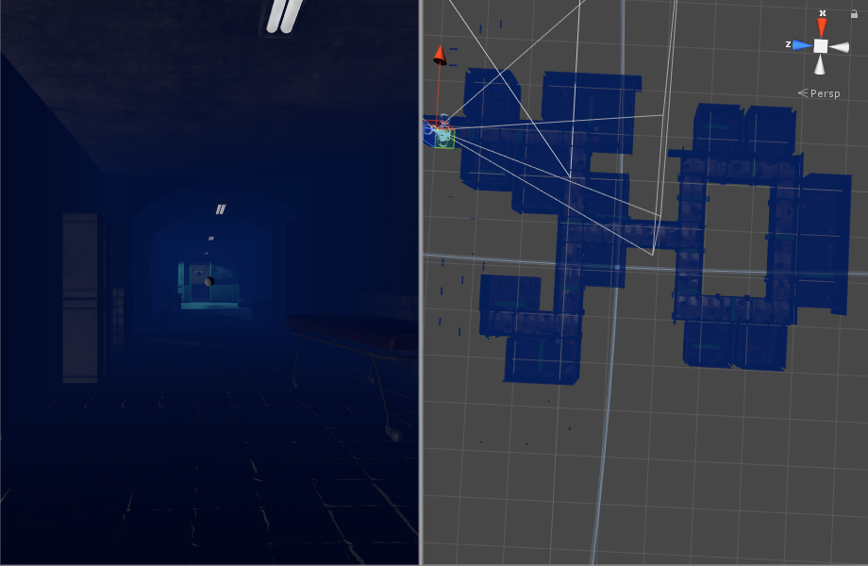
Execution
Based on the deep research on Unity Engine, we luckily found an embedded solution in the engine called Occlusion Culling. Although it is required Pro version for better performance, the free version is good enough for us after tests.
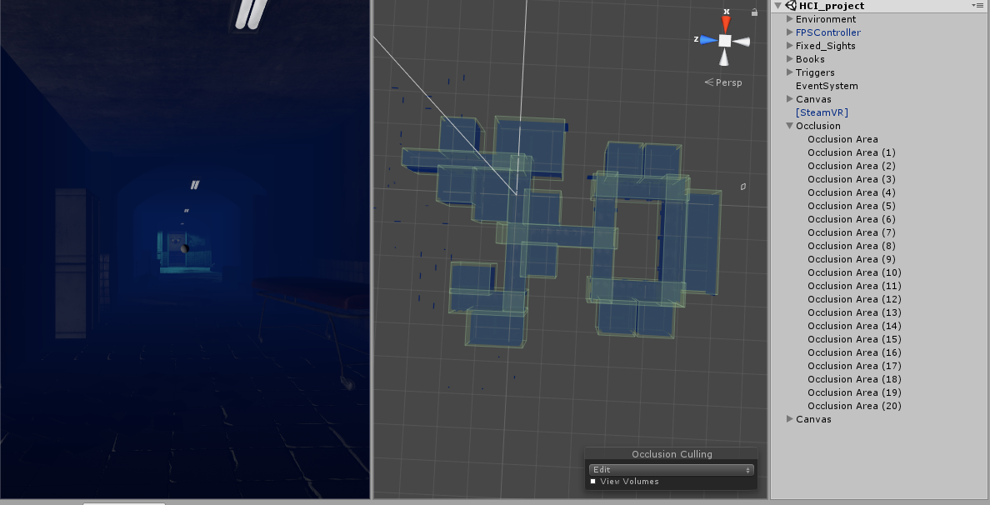
Occlusion Culling is a feature that disables rendering of objects when they are not currently seen by the camera because they are obscured (occluded) by other objects. This does not happen automatically in 3D computer graphics since most of the time objects farthest away from the camera are drawn first and closer objects are drawn over the top of them (this is called “overdraw”). Occlusion Culling is different from Frustum Culling. Frustum Culling only disables the renderers for objects that are outside the camera’s viewing area but does not disable anything hidden from view by overdraw.
The occlusion culling process will go through the scene using a virtual camera to build a hierarchy of potentially visible sets of objects. This data is used at runtime by each camera to identify what is visible and what is not. Equipped with this information, Unity will ensure only visible objects get sent to be rendered. This reduces the number of draw calls and increases the performance of the game.
The data for occlusion culling is composed of cells. Each cell is a subdivision of the entire bounding volume of the scene. More specifically the cells form a binary tree. Occlusion Culling uses two trees, one for View Cells (Static Objects) and the other for Target Cells (Moving Objects). View Cells map to a list of indices that define the visible static objects which gives more accurate culling results for static objects.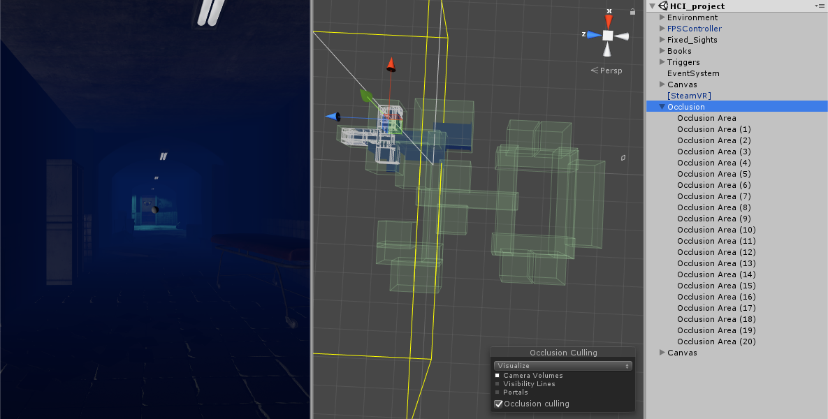
It is important to keep this in mind when creating your objects because you need a good balance between the size of your objects and the size of the cells. Ideally, you shouldn’t have cells that are too small in comparison with your objects but equally you shouldn’t have objects that cover many cells. You can sometimes improve the culling by breaking large objects into smaller pieces. However, you can still merge small objects together to reduce draw calls and, as long as they all belong to the same cell, occlusion culling will not be affected.
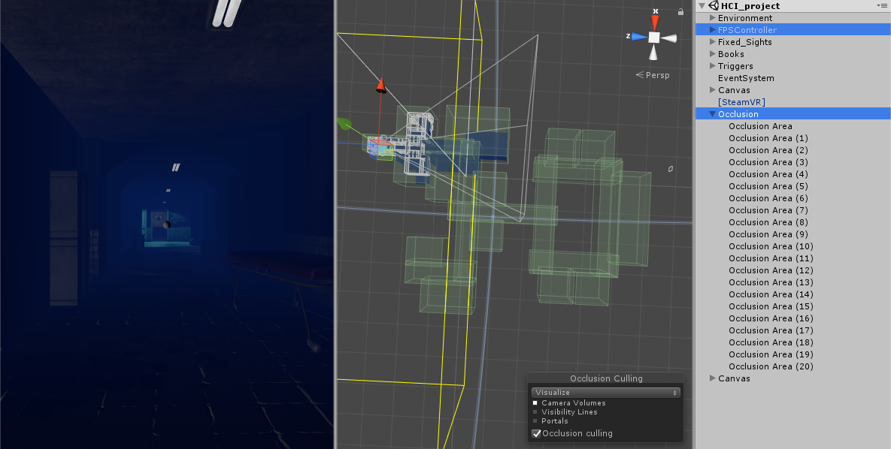
You can use the ‘overdraw’ scene rendering mode to see the amount of overdraw that is occurring, and the stats information pane in the game view to see the amount of triangles, verts, and batches that are being rendered. Below is a comparison of these before and after applying occlusion culling.
In order to use Occlusion Culling, there is some manual setup involved. First, your level geometry must be broken into sensibly sized pieces. It is also helpful to lay out your levels into small, well defined areas that are occluded from each other by large objects such as walls, buildings, etc. The idea here is that each individual mesh will be turned on or off based on the occlusion data. So if you have one object that contains all the furniture in your room then either all or none of the entire set of furniture will be culled. This doesn’t make nearly as much sense as making each piece of furniture its own mesh, so each can individually be culled based on the camera’s viewpoint.
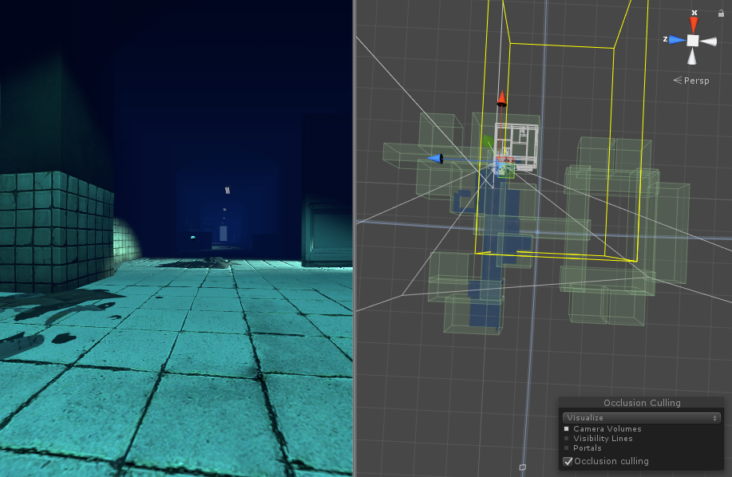
You need to tag all scene objects that you want to be part of the occlusion to Occluder Static in the Inspector. The fastest way to do this is to multi-select the objects you want to be included in occlusion calculations, and mark them as Occluder Static and Occludee Static.
To apply occlusion culling to moving objects you have to create an Occlusion Area and then modify its size to fit the space where the moving objects will be located (of course the moving objects cannot be marked as static). You can create Occlusion Areas by adding the Occlusion Area component to an empty game object (Component -> Rendering -> Occlusion Area in the menus). [3]

Aberration

Vest
As mentioned, 3rd space vest is a technology ten years ago. It is quite limited for the technology nowadays. During the tests we were performing, we ran into several problems with the Gaming Vest, which could have impacted immersion in the VR game. The first problem was the air compressor being extremely loud, sometimes distracting us or the play testers. However, no testers did report of the noise bothering them, they definitely did hear it, which could have effected immersion. 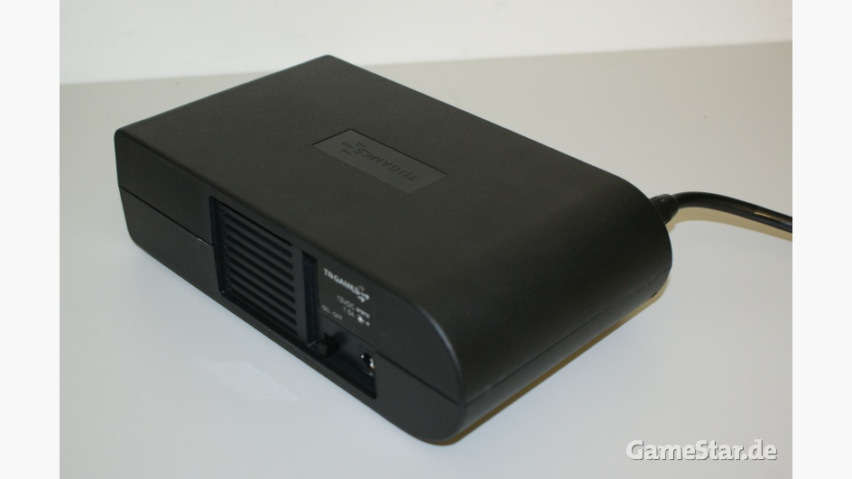
Figure 3. The compressor for the Gaming Vest

When we were testing, the wires connected to the vest became a problem due to its limited length. We found during the tests, the testers were accidently pulling cords by attempting to walk in the game. This became a huge issue, due to a loss of data and an inconvenience to the tester. We attempted to move the computer closer to the play field but we still ran into the short wire problem, which was a huge obstacle. 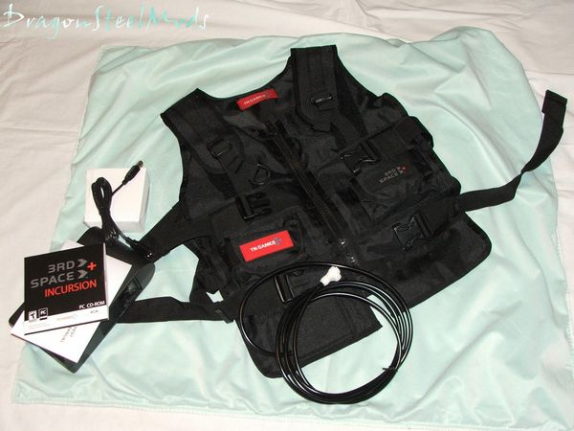
Figure 4. Gaming Vest showing the wires attached

When doing small tests before the major testing with testers, we noticed something with the vest when it activates. When a pocket is activated, the amount of force applied cannot be modified, resulting in the same feeling from the pocket every time. This default pressure was quiet hard for what we needed it for, which was for a light touch. Unfortunately this was uncontrollable and we proceeded with the testing.

Noise
Along with the vest, there is an air compressor that is necessary for compressing air to enable the vest being pump to simulate the “touch”. The downside is quite magnified by its noise while compressing the air to the vest. Although the player is wearing earbuds, the noise from air compressor is too loud to be neglected sometimes that would break the immersion for the player if he/she hears it and feels disconnection between virtual world and reality.

Limited Input/Output
For its age, the functionality is questioned for the usage in the technology nowadays. The integration with Unity3d was the issue initially. In addition to that, the input and output are limited where we can only have controls to trigger certain air bump(s) for at least one second and that is it; there is no extent of bumping for that it is just bumping or not. This is crucial in horror media where the paranormal touch would always be a gentle touch/stroke instead of poking by a sudden air bump.

Controller
Since we are using an analog controller for the test, the physical movement from the player is limited.

Movement Relativity
The player needs to stand still at the center the given area by Vive. The only physical movement would be turning around. And the collision detector is placed relatively at the center of the given area. Thus, there were circumstances where the player’s location was slightly off due to natural movements. That caused collision detection error where the player could not walk out of a room through a door and the collision detector was actually facing against a wall next to the door.

Vive Headset
This is still a problem for state-of-arts even.

Nausea
Nausea is still here no matter what. Although we added a reticle to reduce the sickness by virtual movements, it still appears at certain point depending on the endurance of different players. The average time appears around ten to fifteen minutes which was good for testing so far; however, the bother of the issues lasts.

Orientation
This actually counts the downside of using an analog controller to move to substitute others where the player move according to wherever he/she is looking at instead of the direction where his/her body is facing. This sometimes causes some disconnection if the player notices the issue. Luckily enough, only a few testers mentioned about this issue so far.

Oximeter
In this experiment, we used Apple Watch and FitBit instead of professional oximeters due to low budget and time limit. Compared to professional ones, these two would definitely have some disadvantages as alternatives.

Connection Issue
Both Apple Watch and FitBit are using Wifi connection to mobile phones. The data is displayed in real time, but recorded and synced in mobile. There were several times in the lab where we held the test sessions having Wifi disconnection issue. Thus, some data was lost due to the issue.

Accuracy
Accuracy is always the problem for non-professional devices for scientific researches. The heart rate is counted based on the number of heartbeat during certain period of time. The number would not be precise due to a lot of reasons: the watch was not worn tight enough, reading disconnection due to the Wifi issue, etc.

Wires
This is the major issue that cannot be resolved so far. During the experiment, the player would have more than five wires connecting to the equipment on his/her body. This would cause a lot of problems for the research:
- the player would feel pulled by something while playing; that would break the immersion
- the wires would tangle together; it is hard to maintain and may cause the issue above
- once the first issue happens, some devices would disconnect from the desktop resulting in an unavoidable stop of the research
- while the player is playing and turning his/her body, the wire would tangle his/her legs forcing the player to turn the opposite direction to avoid the tangling; this significantly breaks the immersion

Reference
- Mark Claypool ; Kajal Claypool ; Feissal Damaa; The effects of frame rate and resolution on users playing first person shooter games. Proc. SPIE 6071, Multimedia Computing and Networking 2006, 607101 (January 16, 2006); doi:10.1117/12.648609.
- J. Jie, K. Yang and S. Haihui, "Research on the 3D Game Scene Optimization of Mobile Phone Based on the Unity 3D Engine," 2011 International Conference on Computational and Information Sciences, Chengdu, China, 2011, pp. 875-877.
doi: 10.1109/ICCIS.2011.317
- https://docs.unity3d.com/460/Documentation/Manual/OcclusionCulling.html
- Brown, Emily, and Paul Cairns. "A Grounded Investigation of Game Immersion." Extended Abstracts of the 2004 Conference on Human Factors and Computing Systems - CHI '04 (2004): n. pag. Web.
- Gortari, Angelica B. Ortiz De. "What Can Game Transfer Phenomena Tell Us about the Impact of Highly Immersive Gaming Technologies?" 2015 International Conference on Interactive Technologies and Games (2015): n. pag. Web.
- Patrao, Bruno, Samuel Pedro, and Paulo Menezes. "How to Deal with Motion Sickness in Virtual Reality." (n.d.): 1-7. Web. 20 Apr. 2017.
- Robillard, GeneviÃ¨ve, StÃ©phane Bouchard, Thomas Fournier, and Patrice Renaud. "Anxiety and Presence during VR Immersion: A Comparative Study of the Reactions of Phobic and Non-phobic Participants in Therapeutic Virtual Environments Derived from Computer Games." CyberPsychology & Behavior 6.5 (2003): 467-76. Web.
- Siyan Zhao, Ali Israr, Kaitlyn Schwakje, Roberta Klatzky, and Jill Lehman. "Feel Effects: Enriching Storytelling with Haptic Feedback." (2014): 1-17. Web. 20 Apr. 2017.
- "Valve's VR headset is called the Vive and it's made by HTC". The Verge. Retrieved 10 Feb 2017.
- "TN Games | shop." TN Games | shop. N.p., n.d. Web. 13 Feb. 2017.
- Corriea, Alexa Ray. "How developers are trying to solve motion sickness in video games." Polygon. Polygon, 26 Oct. 2013. Web. 14 Feb. 2017.
- Gera, Emily. "The science of fear: How to measure scares in gaming." Polygon. Polygon, 29 Oct. 2014. Web. 10 Apr. 2017.
- Bower, Emily S., Julie Loebach Wetherell, C. Caroline Merz, Andrew J. Petkus, Vanessa L. Malcarne, and Eric J. Lenze. "A New Measure of Fear of Falling: Psychometric Properties of the Fear of Falling Questionnaire Revised (FFQ-R)." International psychogeriatrics / IPA. U.S. National Library of Medicine, July 2015. Web. 15 Apr. 2017.
- Sandhana, Lakshmi. "Biofeedback-based horror game challenges players to deal with fear." New Atlas - Latest News. New Atlas, 17 Nov. 2013. Web. 19 Apr. 2017.
- BUTTONMASHER . "How the scariest video games use our own minds to terrify us." New Scientist. N.p., 21 Oct. 2015. Web. 13 Apr. 2017.
- Fu, Xiangyi, Dietmar Offenhuber, Ann McDonald, Douglass Scott, Thomas Starr, Kristian Kloeckl, Pedro Cruz, and Nathan Felde. "Horror movie aesthetics: how color, time, space and sound elicit fear in an audience." DRS. N.p., 01 Aug. 2016. Web. 17 Apr. 2017.
- "HTC Vive Tutorial for Unity." Ray Wenderlich. N.p., n.d. Web. 15 Mar. 2017.
- "Getting Started with SteamVR and Unity 5.5 [Updated]." Unity3D.College. N.p., 03 Jan. 2017. Web. 22 Mar. 2017.

